URSI Benelux Forum 2025

**Jaarbeurs Utrecht**

**Jaarbeursplein 6  
3521 AL Utrecht  
The Netherlands**

Deadline Abstract Submission:

**August 11, 2025**

Deadline pre-registration:

**September 5, 2025**

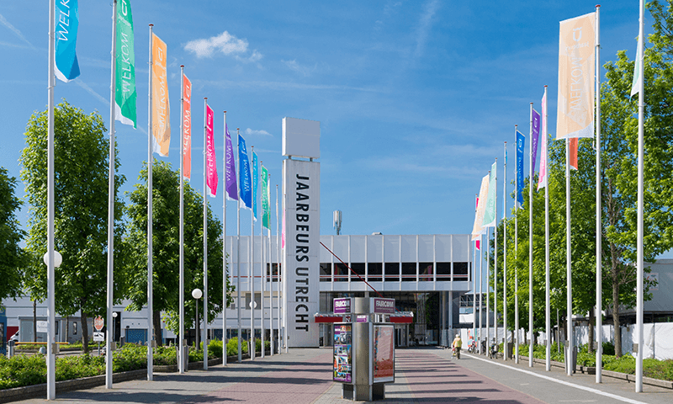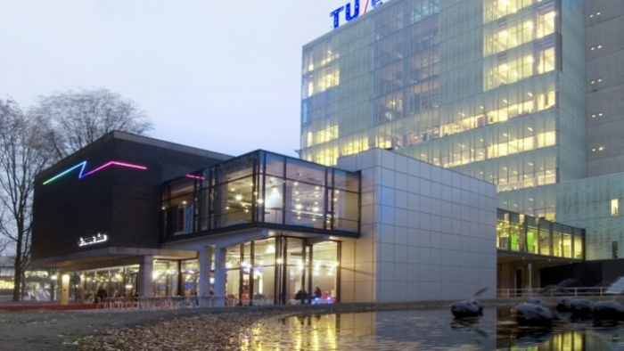

***Registration form***

First name* :

Last name* :

Affiliation :

Address :

City :

Postal code :

e-mail* :

Dietary restrictions :

*=Required field

Please send this registration form to [wijnholds@astron.nl](mailto:wijnholds@astron.nl).

Note: your registration will only be valid once the registration fee has been received on **IBAN NL47 RABO 0141 3437 29** of the **St. Wet. Act. van het NUC** with reference **URSI Forum 2025 and your name**. For this, you can also use the appropriate QR code provided with the registration form.